Aeronautical Information Publication Airspace - Civil Aviation Administration (Luye Plateau Launch Site vicinity)
Flight Guide 5.3.1.1 Civil Aviation Training Airspace - Taitung Rift Valley Training Area (9500FT-3500FT)  22°55'36.0"N 121°07'36.0"E  22°56'05.0"N 121°06'46.0"E  23°06'08.0"N 121°10'36.0"E  23°07'31.0"N 121°13'11.0"E  23°05'53.0"N 121°22'47.0"E  22°57'15.0"N 121°17'35.0"E  Civil Aviation Training | 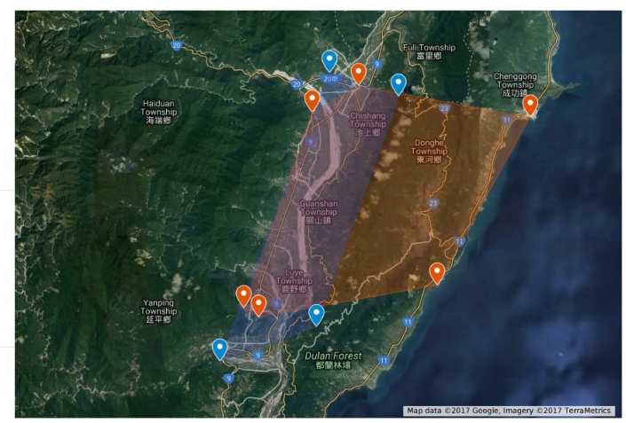
Flight Guide 5.5.2 Hot Air Balloon Airspace - Taitung Luye Plateau Launch Site Hot Air Balloon (2500FT-SFC)
(762M-Ground)
23°08'10.0"N 121°11'34.0"E
23°06'58.0"N 121°15'25.0"E
22°55'06.0"N 121°10'50.0"E
22°53'20.0"N 121°05'26.0"E
Hot Air Balloon Airspace
Taitung Rift Valley Training Area
(9500FT-3500FT)(2896M-1067M)

Taitung Luye Plateau Launch Site Hot Air Balloon Airspace
(2500FT-SFC)(762M-Ground)

